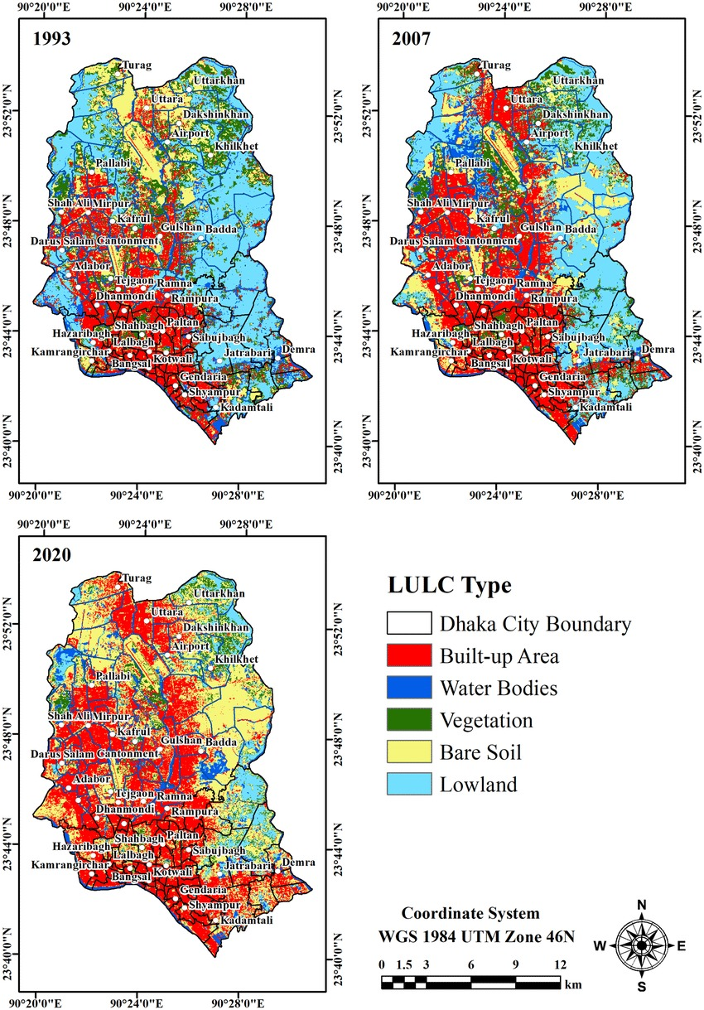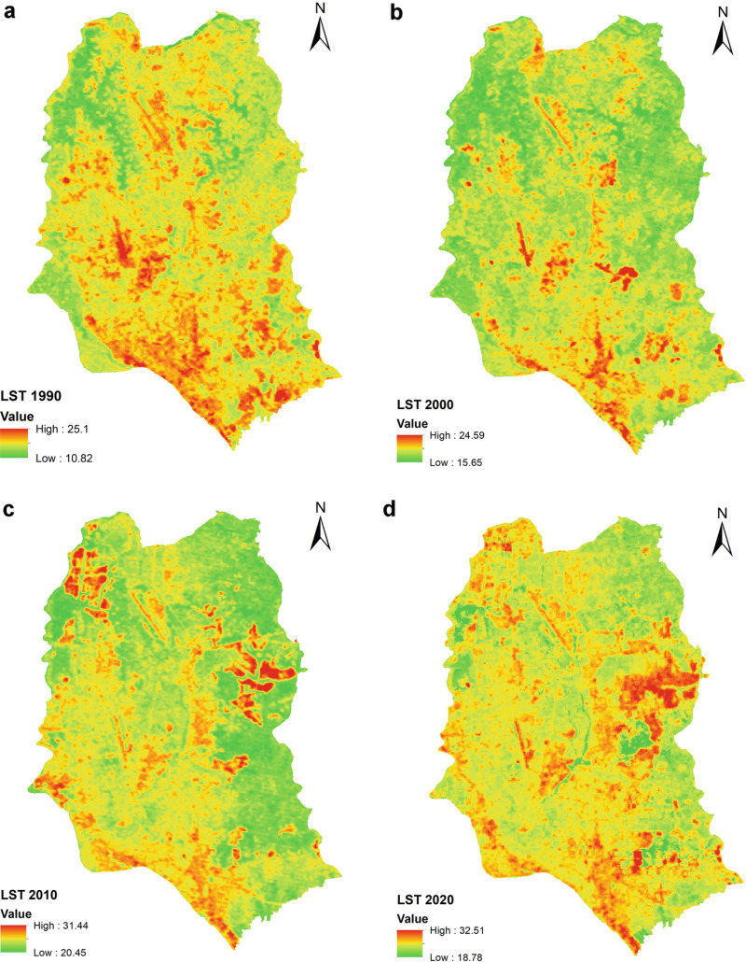

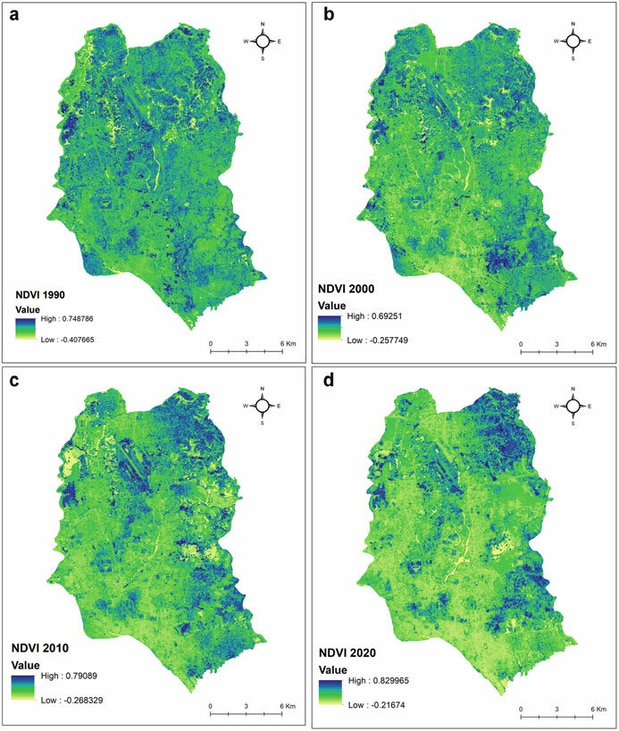

SOURCE

<https://www.researchgate.net/figure/Land-cover-map-of-Dhaka-City-for-the-years-a-1993-b-2007-and-c-2020_fig2_353048462>

for flood data

<https://flood-api.open-meteo.com/v1/flood?latitude=59.91&longitude=10.75&daily=river_discharge&start_date=2025-09-30&end_date=2025-10-30&timeformat=iso8601>

air quality

<https://air-quality-api.open-meteo.com/v1/air-quality?latitude=52.52&longitude=13.41&hourly=pm10,pm2_5>

population

<https://geocoding-api.open-meteo.com/v1/search?name=Berlin&count=10&language=en&format=json>

nasa data

<https://earthobservatory.nasa.gov/>

<https://www.earthdata.nasa.gov/>

<https://worldview.earthdata.nasa.gov/>

<https://giovanni.gsfc.nasa.gov/giovanni/#service=TmAvMp&starttime=&endtime=&variableFacets=dataFieldDiscipline%3AAerosols%3B>

Google Earth Engine

<https://code.earthengine.google.com/>